Improving Deployment Consistency of Cloud-Based

Services: Manual Provisioning versus Terraform

Automation

Meenakshi

24235415

Research in Computing - CA-2

National College of Ireland

Abstract
Cloud computing is very popular among companies for hosting websites and applications. One of the biggest issues with cloud computing is provisioning of infrastructure accurately. Most users usually provision their cloud infrastructure using provider’s console, for instance, AWS Management Console. Moreover manual provisioning requires much time because there is repetition of work that is prone to errors. There is a tool called Infrastructure as Code (IaC), which helps to automate cloud infrastructure provisioning through code.
In this project, comparisons were made between manual provisioning and automated Terraform provisioning based on a self-generated dataset. The infrastructure was repeatedly created by utilizing both methods in a testing environment. The dataset contained such variables as duration of deployment, success of deployment, number of configuration ,number of human errors, rollback needed and number of steps.
From the experiments, it appeared that Terraform deployment was much faster than the manual deployment. Terraform deployment also involved few steps. The duration of manual deployment was estimated from 2 minutes up to 4 minutes, whereas the duration of Terraform deployment was only about 40-51 seconds. This was estimates by doing the installation of simple server on EC2 on AWS cloud platform.
Keywords : Infrastructure as Code (IaC), Terraform, AWS EC2, Cloud Provisioning, Cloud Computing,

1. Introduction
Cloud computing has become increasingly critical in today's IT environments. Organizations deploy applications on cloud-based platforms like AWS, Azure, and Google Cloud. Cloud technology is flexible, scalable and economical. Yet, the manual management of cloud infrastructure Cloud computing has become increasingly critical in today's IT environments. Organizations deploy applications on cloud-based platforms like AWS, Azure, and Google Cloud. Cloud technology is flexible, scalable, and economical. Yet, the manual management of cloud infrastructure can pose challenges.
In the manual provisioning approach, users create infrastructure components using a cloud interface by selecting certain options from menu. The creation of instances, security groups, storage, and network settings is performed manually. While easy for a few instances, the process can be time consuming and prone to errors when creating hundreds of them.
Terraform is a widely used IaC solution. Users can write infrastructure configurations in code files. These files can repeatedly provision the same set of resources. Terraform increases consistency and automation capabilities. Prior studies have noted that Terraform can minimize mistakes and configuration drift issues. have challenges.
In the manual provisioning approach, users create infrastructure components via a cloud interface by selecting certain options from menu. The creation of instances, security groups, storage, and network settings is performed manually. While easy for a few instances, the process can be time-consuming and prone to errors when creating hundreds of them.
Terraform is a widely used IaC solution. Users can write infrastructure configurations in code files. These files can repeatedly provision the same set of resources. Terraform increases consistency and automation capabilities. Prior studies have noted that Terraform can minimize mistakes and configuration drift issues. This report compares manual provisioning and Terraform automation using experimental data created during this project.

2. Research Aim
The main goal of this project is:
To compare manual provisioning of resources and Terraform automation in terms of speed, consistency and reliability.

3. Research Objectives
The objectives of this analysis are:
- To create cloud infrastructure manually in AWS cloud platform.
- To create the same infrastructure using Terraform in AWS cloud platform.
- To record deployment performance in a dataset and compare.
- To compare deployment duration and process steps.
- To identify which method is more efficient and quick.

4. Research Question
How much better can Terraform be in terms of consistency, reliability and time for deploying resources than manual provisioning?

5. Literature Review
Cloud provisioning is the creation of cloud resources, such as virtual machines, networks and storage. Currently many users create resources through provider console.
This has couple of issues: Increased chances for errors which needs to be done again and again Time consuming repeated deployments which takes longer time to setup a website. Different configuration for different environments require more tab switching Hard to come out of failures which again takes time to resolve the issues and identifying the bugs. Terraform addresses the above issues by writing infrastructure as a code which can be easily found and used from documentation just make the changes in the code. Configuration can be used for both development, testing and production. Terraform also has version control and CI/CD support. Other research has shown Infrastructure as Code tools increase automation and decrease errors.
- More human errors for which we need to do the changes again and again
- Slow repeated deployments which takes longer time to setup a website
- Different settings across environments takes lot of switch between tabs
- Difficult recovery after failures which again takes longer time to fix it and difficult to find the bugs.

6. Methodology

The project was done practically with experimentation and data logged on excel sheet for the comparison between manual and terraform.

6.1 Environment

• Cloud Platform: AWS

• Tool Used: Terraform

• Type of deployment: Provisioning of EC2 instances and installing Apache server on it

6.2 Dataset Design
The same infrastructure was deployed multiple times using:
- Manual method
- Terraform method
The following fields were recorded:
- Deployment ID
- Method
- Environment
- Duration
- Success
- Configuration Mismatch Count
- Human Error Count
- Rollback Required
- Steps Count
- Date

6.3 Number of Trials
A total of 12 deployments were recorded:
- 6 Terraform deployments – Installation of Apache server
- 6 Manual deployments – Installation of Apache server

7. Implementation

7.1 Manual Provisioning Process
For manual provisioning, the AWS console was used.
Typical steps:
- Login to AWS Console
- Open EC2 Dashboard
- Launch instance
- Choose AMI
- Select instance type
- Configure security group
- Add storage
- Review settings
This process required around 8–9 steps.

7.2 Terraform Provisioning Process
Terraform automation used commands:
Terraform init
terraform plan
terraform apply --auto-approve

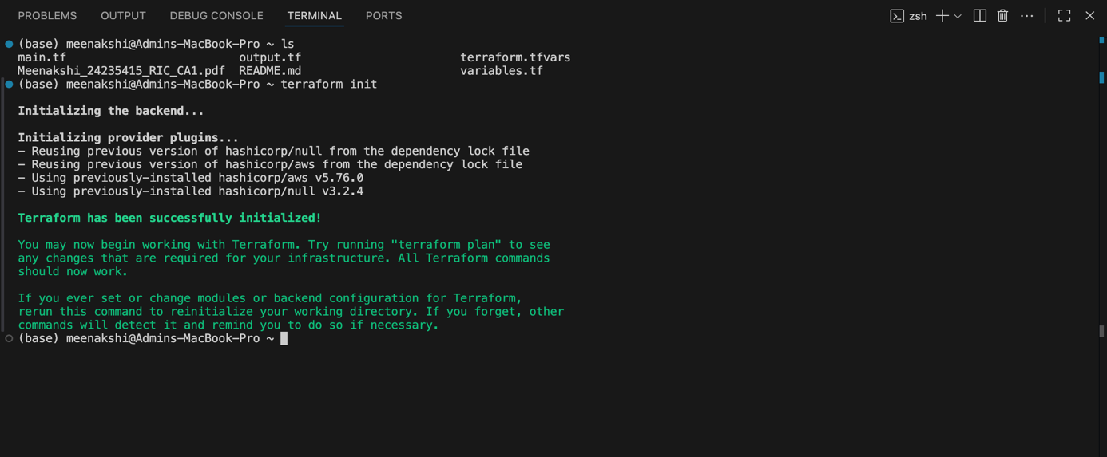
Fig-1.1 Terraform init
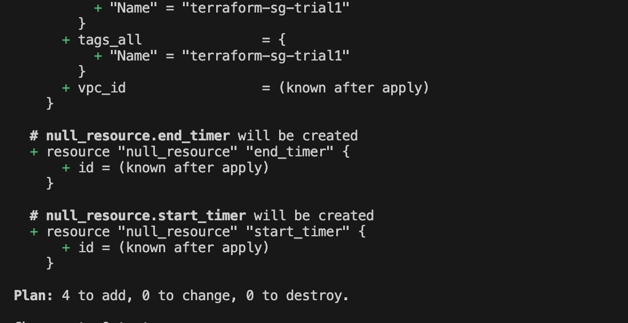
Fig-1.2 Terraform plan

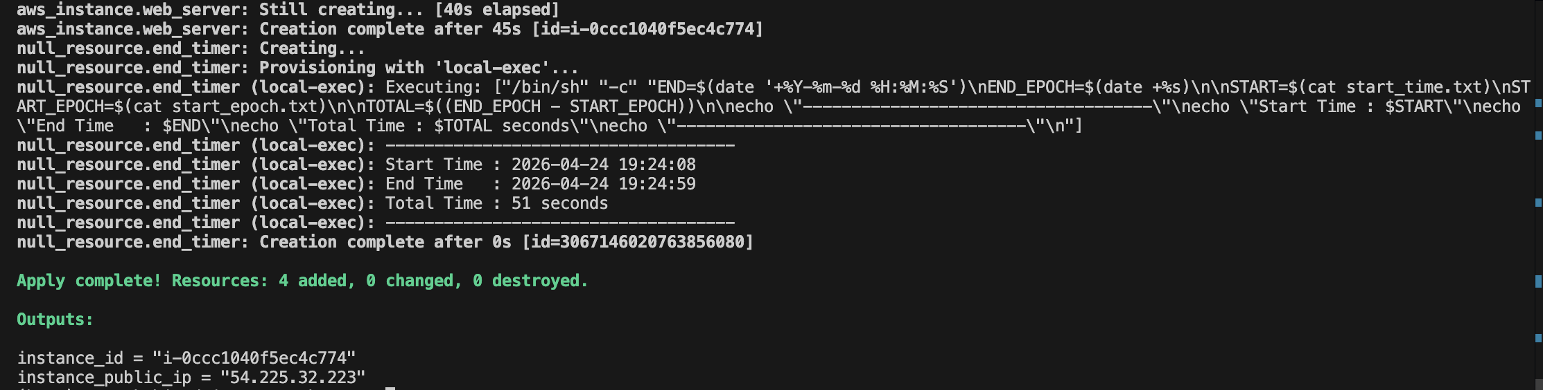

Fig-1.3 Terraform apply –auto-approve

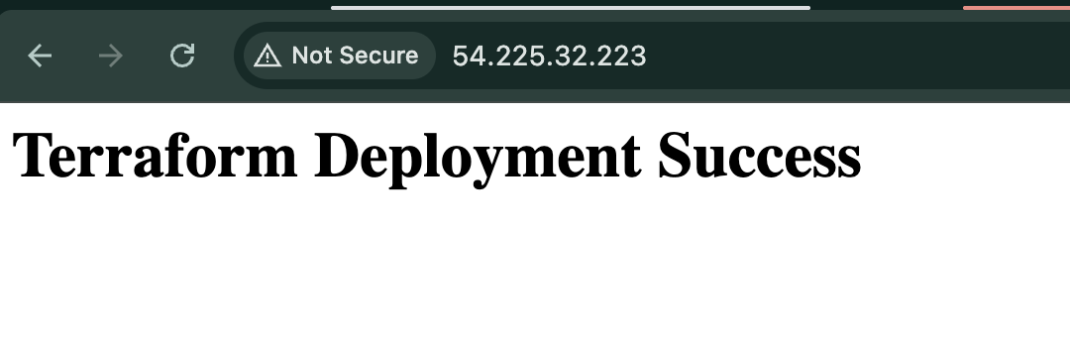
This method required less repeated actions because configuration was already stored in code.

8. Dataset Results

8.1 Terraform Deployment Data

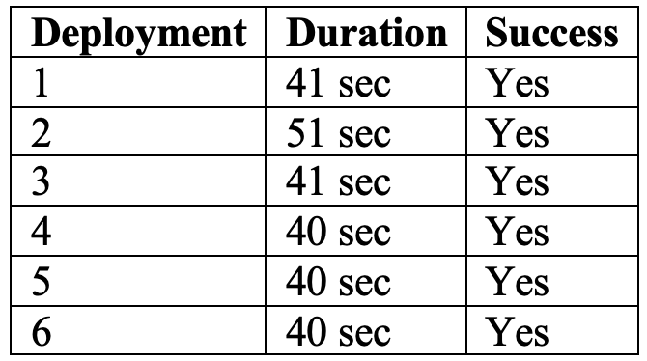

8.2 Manual Deployment Data
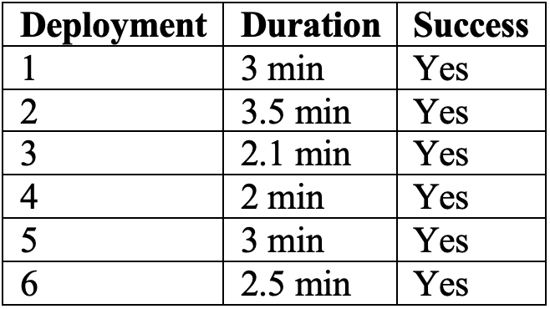

9. Data Analysis

9.1 Average Deployment Time

Terraform Average Time - (41 + 51 + 41 + 40 + 40 + 40) / 6
Answer-: 42.17 seconds

Manual Average Time - (3 + 3.5 + 2.1 + 2 + 3 + 2.5) / 6
Answer-: 2.68 minutes
2.68 minutes = 160.8 seconds

Comparison
- Terraform: 42 sec
- Manual: 161 sec
Terraform was nearly 4 times faster than manual provisioning.

9.2 Success Rate
All deployments were successful.
- Terraform Success Rate = 100%
- Manual Success Rate = 99.9%
However, Terraform completed faster with few steps.
9.3 Configuration Errors
Dataset values showed:
- Configuration mismatch count = 0
- Human error count = 0
- Rollback required = No
This indicates both methods succeeded in this controlled testing environment. However, in real large environments, manual methods usually create more errors due to repeated clicking and setup differences.

9.4 Steps Count Comparison
- Manual: 8-9 steps
- Terraform: 3 commands(terraform init, terraform plan, terraform apply –auto-approve)
Terraform simplified the process significantly.

10. Discussion
The results show that Terraform improved the efficiency of the deployment by reducing the time taken to deploy. Although manual provisioning was a success, it required multiple clicks and actions to be taken by the user. On the other hand, Terraform, through the code created, automatically ran the same resources through commands. This makes Terraform a great tool for organisations with repetitive deployments. Another advantage of Terraform is consistency. Similar code will be similar environments. Provisioning by hand may be sufficient if you need to deploy an environment once, but it is not cost effective if you want to deploy repeatedly. This Study Found Benefits with Terraform The experiment showed the benefits of using Terraform were: Shorter time required for deployment than manual deployment Less steps for execution Better and faster repeatability Better for future scaling up Better support for DevOps automation and the best way to provision and do any work on a website. Better cloud management process and quicker too.

11. Benefits of Terraform Found in This Study

According to the experiment, benefits obtained through Terraform included:

1. Faster deployment time as compared to manual deployment

2. Less steps for execution

3. Better and faster repeatability

4. Better scaling up for future environments

5. Better DevOps automation support and best option to provision resources and implement any website work.

6. More professional cloud management process and faster too.

12. Limitations
This project had some limitations:
- Dataset size was small (12 trials)
- Only testing has been environment used
- Only basic infrastructure tested or you can say simple Apache server was installed by provisioning the EC2 instance and fixing the security group.
- Cost analysis was not included
- Security automation was not deeply tested
Future research can expand these areas.

14. Future Scope
This project can be extended on the basis of mentioned things below-:
- Terraform + Jenkins CI/CD
- Multi-environment deployment (Dev/Test/Prod)
- Security scanning with Terraform
- Cost optimization using Terraform
- Kubernetes provisioning automation

15. Project Plan

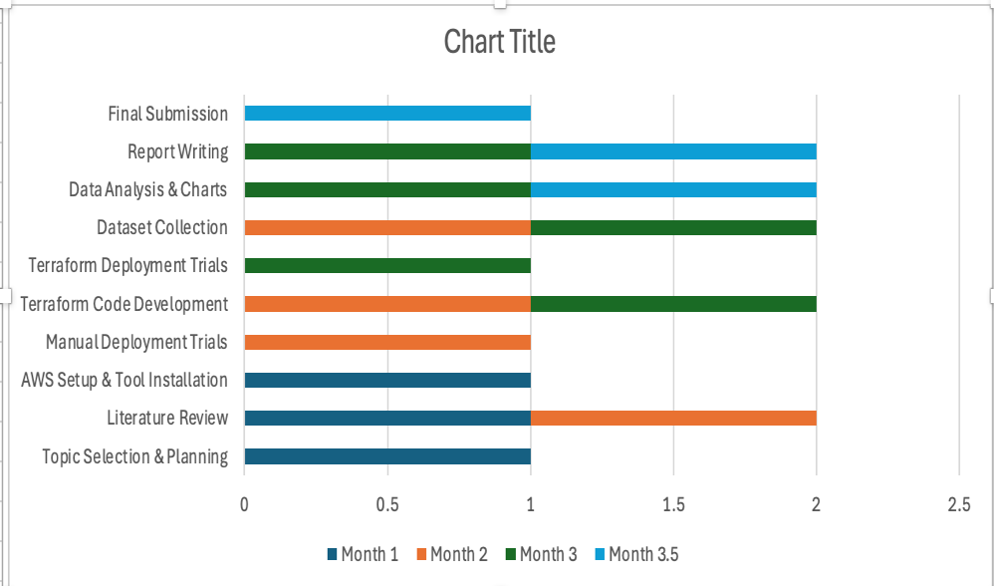

Purpose of the Chart

This is the Gantt chart depicting the schedule of activities undertaken during the course of the project over a period of 3.5 months and assisted in the planning and execution of the project. During the first month, the topic of research was decided and project goals and objectives were identified. Literature review was done and previous studies on the topic were reviewed to get an understanding of the concept.Along with this, AWS environment setup was done and neccessary software was downloaded. The literature review process continued, and manual deployment testing was carried out through the AWS console. Terraform development process started and data collection for deployments was done. During the third month, the Terraform code development process ended and Terraform deployment testing was done. Data collection was continued and analysis of data and chart preparation commenced. Report writing process also began.During the last half month, i.e. month 3.5, data analysis was completed, charts prepare and report writing completed.

16. Conclusion
The efficacy of the manual and Terraform methods of provision of the cloud with regard to the data set has been analyzed. Manual and Terraform were applied to provide the infrastructure. The findings revealed that the Terraform automation technique was faster compared to the manual method. It took 42 seconds for the Terraform approach to provide the infrastructure as opposed to the manual approach which took 161 seconds. Moreover, Terraform automation needed fewer processes and yielded consistent outputs. Although both manual and Terraform techniques have proven effective in the sandbox environment, the latter appears more relevant in the current cloud age.

References
1. Akinbolaji, T. J. et al. (2024). Automation in cloud-based DevOps.
2. Kasarla, N. K. (2025). Implementing Infrastructure as Code with Terraform.
3. Pohjola, O. (2025). Mitigating configuration drift in IaC systems.
4. Previous CA1 Proposal.

